Project Initialization and Planning Phase
Team ID | MCA
Project Name | Smartphone Usage, Digital Addiction & Well-Being Analytics
Maximum Marks | 3 Marks

Define Problem Statements:
Create problem statements from the customer's point of view. The statements below describe who the users are, what they are trying to achieve, the barriers they face, why those barriers exist, and how the problem affects them.

I am | a smartphone user / digital product user
I'm trying to | understand and manage my smartphone usage
But | I do not clearly know which habits or factors are linked to smartphone addiction
Because | screen-time behavior, lifestyle habits, stress, and demographic factors may influence usage patterns
which makes me feel | concerned and frustrated because targeted digital well-being support cannot be planned effectively

Example :
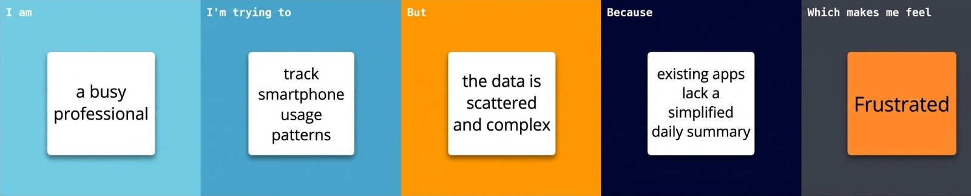
Customer Problem Statements
Problem Statement (PS) | I am (Customer) | I’m trying to | But | Because | Which makes me feel
PS-1 | A busy working professional managing tight everyday schedules | Order fresh groceries quickly and reliably using my smartphone | The application frequently lags or crashes during checkout | The server gets overloaded and the code lacks optimal mobile responsiveness | Frustrated and anxious about missing cooking windows
PS-2 | A budget-conscious student looking for local academic resources | Find and purchase affordable reference textbooks online | It takes a long time to locate trusted sellers or valid listings | The search filters are unorganized and lack location-based sorting options | Overwhelmed and discouraged by the time wasted searching

